**Using A Repository**

**Instructions**

**Learning Objectives**

* Create a repository
* Clone a repository
* Commit a new file to the repository
* Push to a repository

**Source Content**

**Step 1:** Create a new repository on your Github account named *repo-exercise*. Ensure that *Add a README file* is selected.

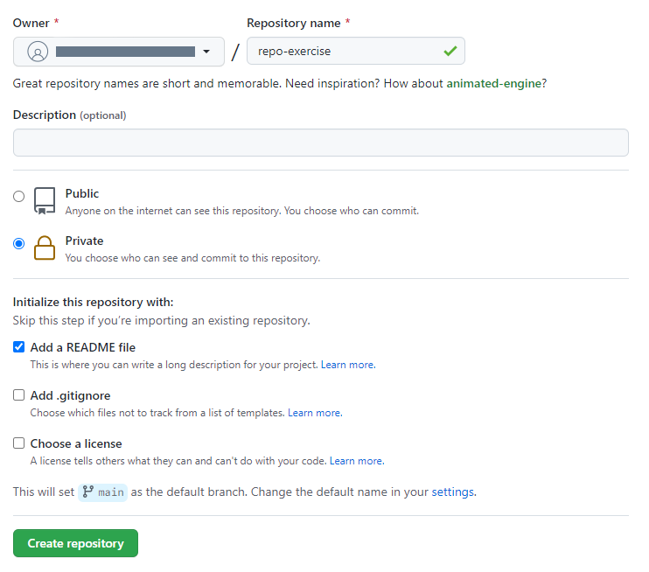

**Step 2:** Open the Terminal and authenticate using gh (Github CLI):

gh auth login

**Step 3:** Create an authentication token in your Github account with specified scopes given in the terminal. Copy it from Github and paste it. Verify authorization was successful.

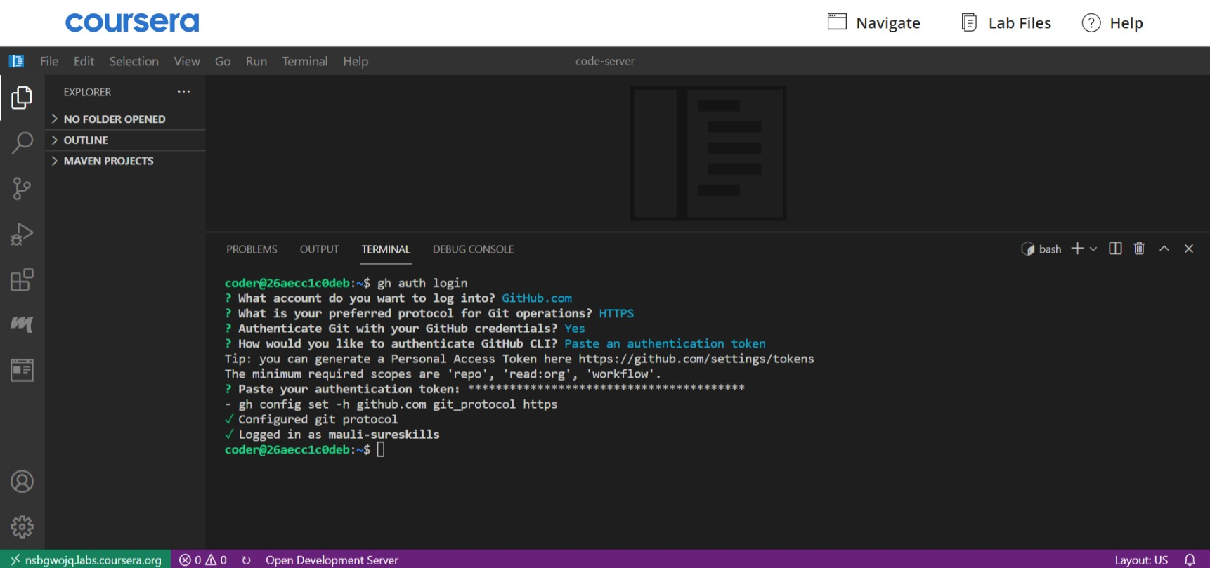

**Step 4:** Clone the repository using its GitHub CLI.

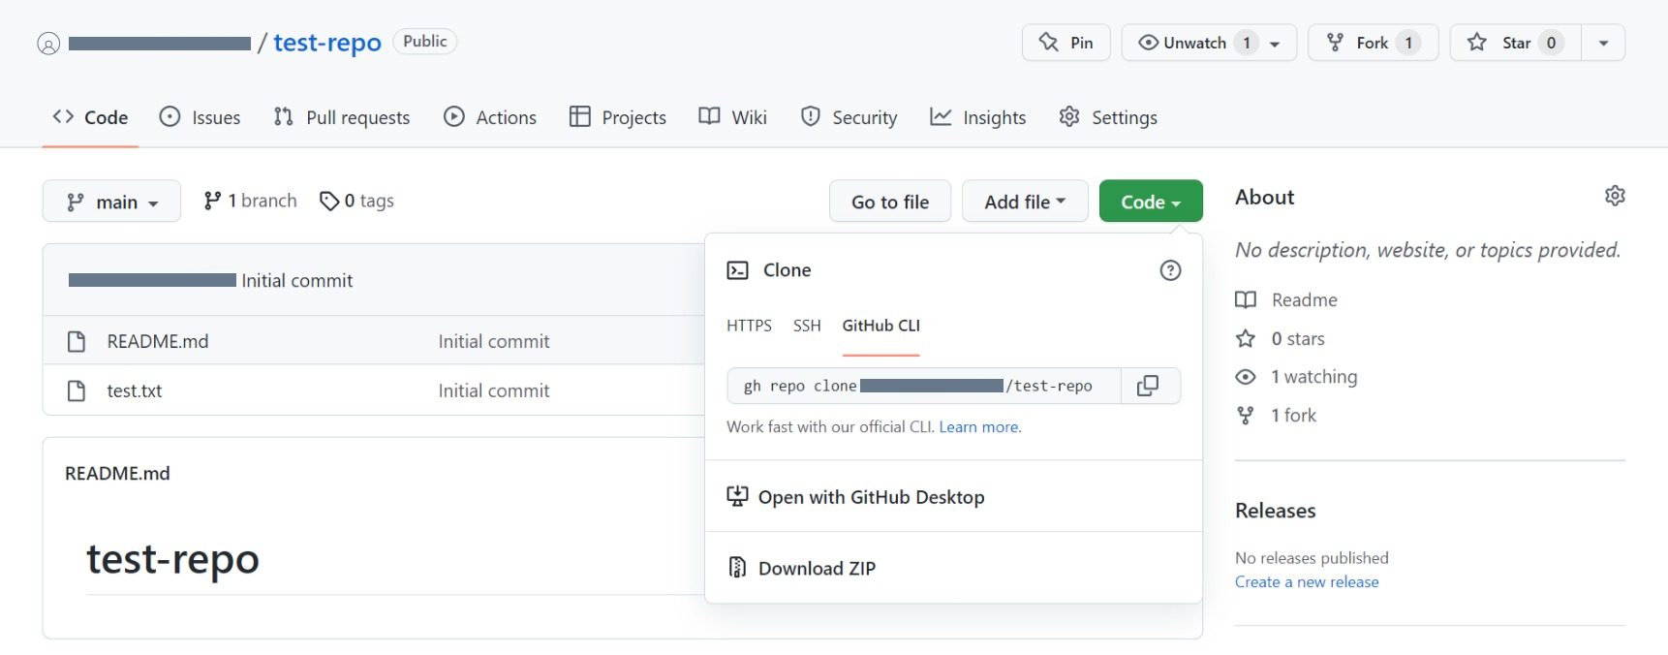

*gh repo clone <YOUR USERNAME>/<REPOSITORY-NAME>*

**Step 5:** Move to the repo directory by using *cd <REPOSITORY-NAME>*

**Step 6:** Add the  *result.txt* to the repository folder.

**Step 7:** In the Git terminal, run the *git status* command

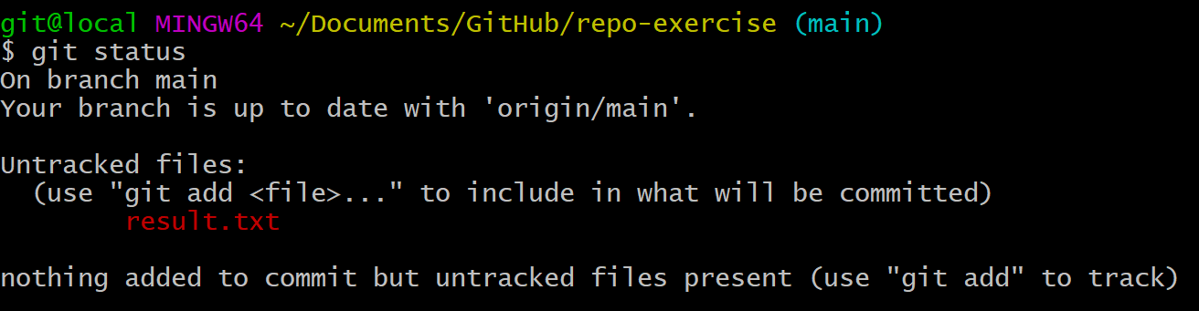

**Step 8:** Verify that the output shows *result.txt* as an untracked file.

**Step 9:** Run the command *git add result.txt*

**Step 10:** Run the *git status* command again.

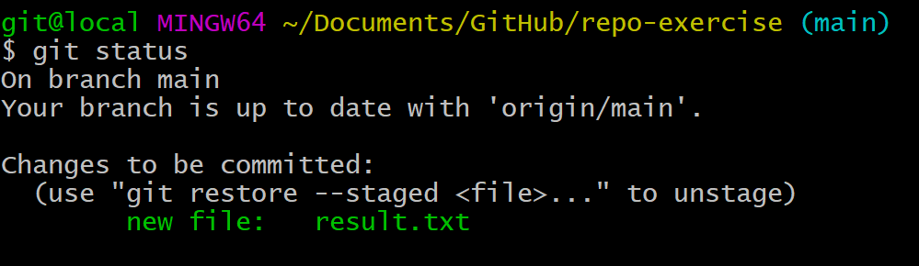

**Step 11:** Verify that the output shows *result.txt* as a tracked file.

**Step 12:** Next, run the *git commit* command and specify the commit message as *Successful exercise*

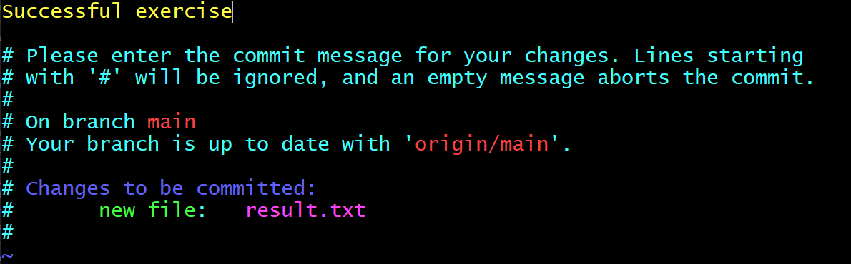

**Step 13:** Verify that the output shows *result.txt* with create mode

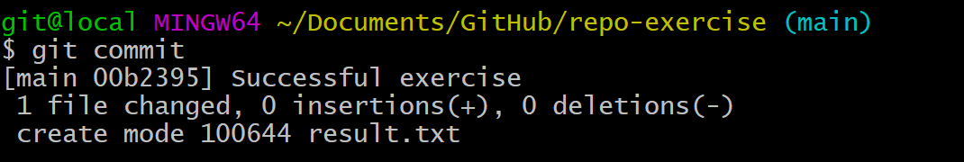

**Step 14:** Next, run the *git push* command.

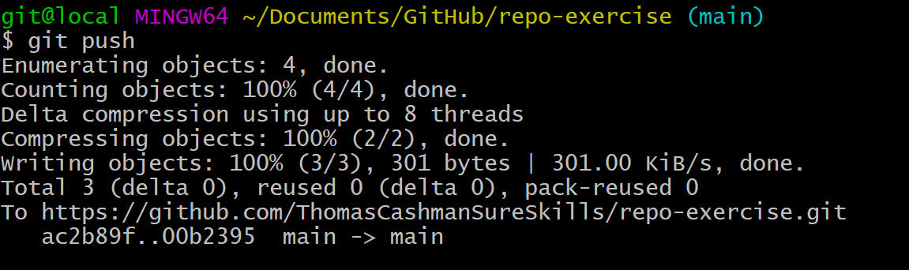

**Step 15:** Verify that the output pushed successfully.

**Step 16:** On Github, go to your repository page.

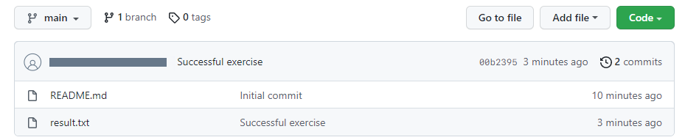

**Step 17:** Verify that the *result.txt* file is listed. You may need to refresh the page to see the changes.

Congratulations! You have completed this exercise.